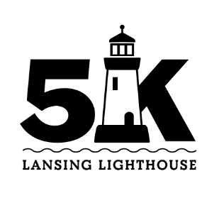
5K Map
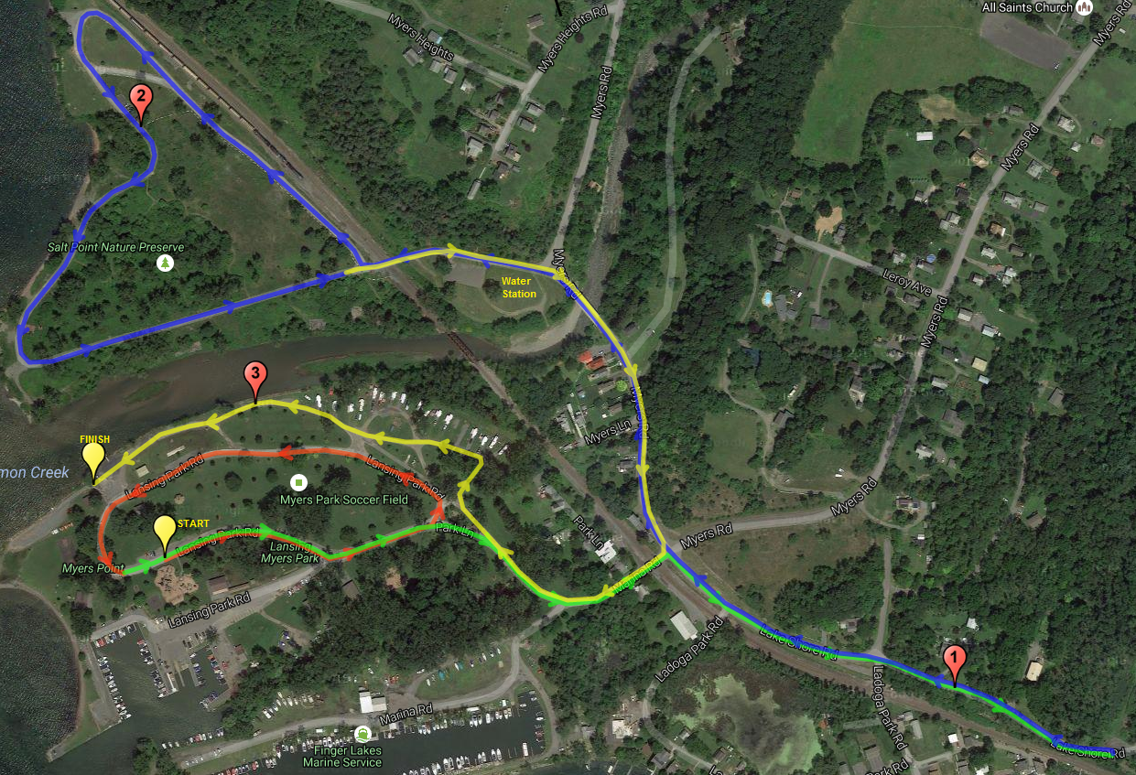
(Course route indicated on map with red, then green, blue, yellow arrows)

