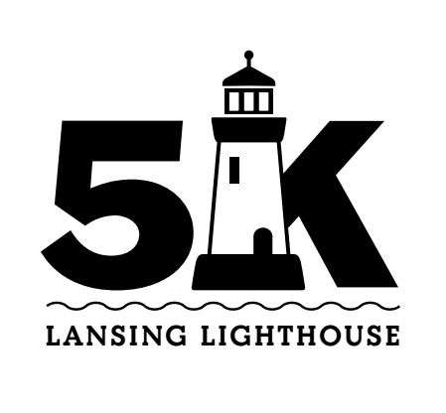

**Fun Run Map**

(Course route indicated on map with red, then green arrows)

